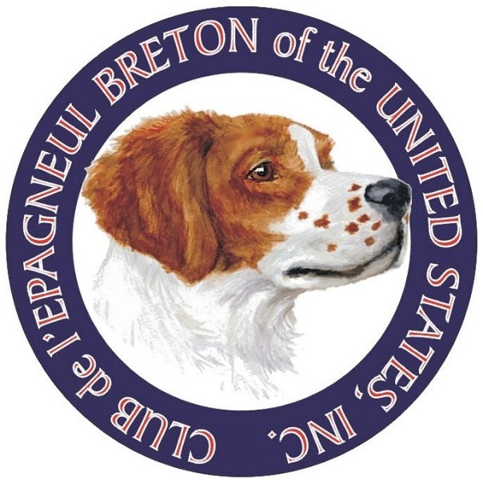
JOYCE SMITH MEMORIAL SCHOLARSHIP

Club de l’Epagneul Breton of the United States

The Joyce Smith Memorial Scholarship Fund was established to assist graduating high school students entering college to pursue an accredited course of study. The fund was created in honor and memory of Joyce Smith, a founding member of what is now the Club de l’Epagneul Breton of the United States. A memorial of Joyce’s contributions can be found in issue 33, page 5, of the CEB-US club magazine L’Epagneul Breton as well as on the Epagneul Breton Foundation official website located at www.epagneulbretonfoundation.org (Select the Support Us website page and access the Scholarship tab).

Successful applicants will meet the following listed criteria:
- Graduate from high school during current academic school year
- Member of CEB-US as an individual youth or child of a family membership for the continuous past three (3) years.
- Student applicant can demonstrate substantial reasonable involvement with the Epagneul Breton over a sustained period of time by participation in breed related activities as set forth in the application. Substantial involvement may be further demonstrated by participation in other activities advocating and promoting the Epagneul Breton in publications, media, or via participation in school, agricultural or community organizations.
- Applicant will submit a written essay with a minimum of 1000 words and maximum of 3000 words, suitable for the club magazine, telling how the interaction with the Epagneul Breton has impacted his or her life.
- Applicant is accepted for admission and enters an accredited college or university.
- Application is received by deadline date of entry which is February 15 of the year in which the applicant will graduate and anticipate enrolling in college.
- Applicant shall submit three (3) to five (5) photographs suitable for publication which depict the applicant engaged in activities with Epagneul Bretons.
Please send the following Application Form, Applicant/Parental Certification and supporting materials to:
Ed Smith, Chairman
CEB-US Scholarship Committee
13264 S. 1025 E.
Galveston, IN 46932
Email: ejs1029@aol.com
Also please email a copy of the application and supporting materials to the current CEB-US President.

Certification Of Application & Release/Acknowledgements By Applicant And Parent

I hereby certify to the board of the CEB-US and the Selection Committee of the Joyce Smith Memorial Scholarship Fund, that the information provided as a part of this application process as well as any information I provide in an interview is true, correct and complete to the best of my knowledge as of submission of this application.
I hereby acknowledge and understand that the Joyce Smith Memorial Scholarship Fund is awarded on behalf of the Club De L’Epagneul Breton of the United States (“CEB-US”), which is designated as a nonprofit entity under section 501(c)(7) of the U.S. Internal Revenue Code. I further acknowledge and understand that the Joyce Smith Memorial Scholarship
Fund is held and managed for investment for CEB-US by The Epagneul Breton Foundation, Inc. (“the Foundation”) which is designated as a charitable non-profit entity under section 501(c)(3) of the U.S. Internal Revenue Code, and that the Foundation disburses scholarship proceeds on behalf of CEB-US to selected scholarship recipients.
I hereby acknowledge and agree that any decision made concerning my scholarship application by the designated Scholarship Selection Committee shall be final and shall be made in the sole discretion of the Scholarship Selection Committee under established selection criteria. Accordingly, I hereby agree and covenant not to attempt to assert any claim, cause of action or right of appeal against the Joyce Smith Memorial Scholarship Fund, the Joyce Smith Memorial Scholarship Selection Committee, CEB-US, the Foundation, or any member(s) thereof those entities relating to my scholarship application or any decision relating thereto.
I hereby acknowledge and understand that any scholarship award conferred is a onetime stipend, and that the amount of the award is in the sole discretion of the CEB-US Scholarship Committee based on the amount of funds available and the number of applicants awarded in the particular academic school year under consideration.
I hereby expressly authorize the CEB-US Joyce Smith Memorial Scholarship Fund, CEB-US and the Foundation the right to use my name, likeness and image for publicity related to this scholarship application and any related scholarship award. Further, in consideration of my scholarship application being placed under consideration for selection, I hereby agree to release, remise, and agree to indemnify and hold harmless the Joyce Smith Memorial Scholarship Fund, CEB-US, the Foundation and their members and representatives from any claim, demand, or potential cause of action for damages related to this scholarship application, the making or publication of the scholarship award, or any lack thereof.

Applicant Signature: _______________________________Date: _______________________

Parental Certification

I certify that the information in the foregoing application pertains to my son / daughter is true and correct. That I have read, understand, acknowledge and affirm the foregoing certification of my child.
I hereby authorize the CEB-US Joyce Smith Memorial Scholarship Fund, CEB-US and the Foundation the right to use my child’s name, likeness and image for publicity purposes related to this scholarship application and any related scholarship award. Further, in consideration of my son or daughter’s scholarship application being placed under consideration for selection, I hereby agree to release, remise, and agree to indemnify and hold harmless the Joyce Smith Memorial Scholarship Fund, CEB-US, the Foundation and their members and representatives from any claim, demand, or potential cause of action for damages related to this scholarship application, the making or publication of the scholarship award, or any lack thereof.

Parent Signature: _____________________________________ Date: ____________________

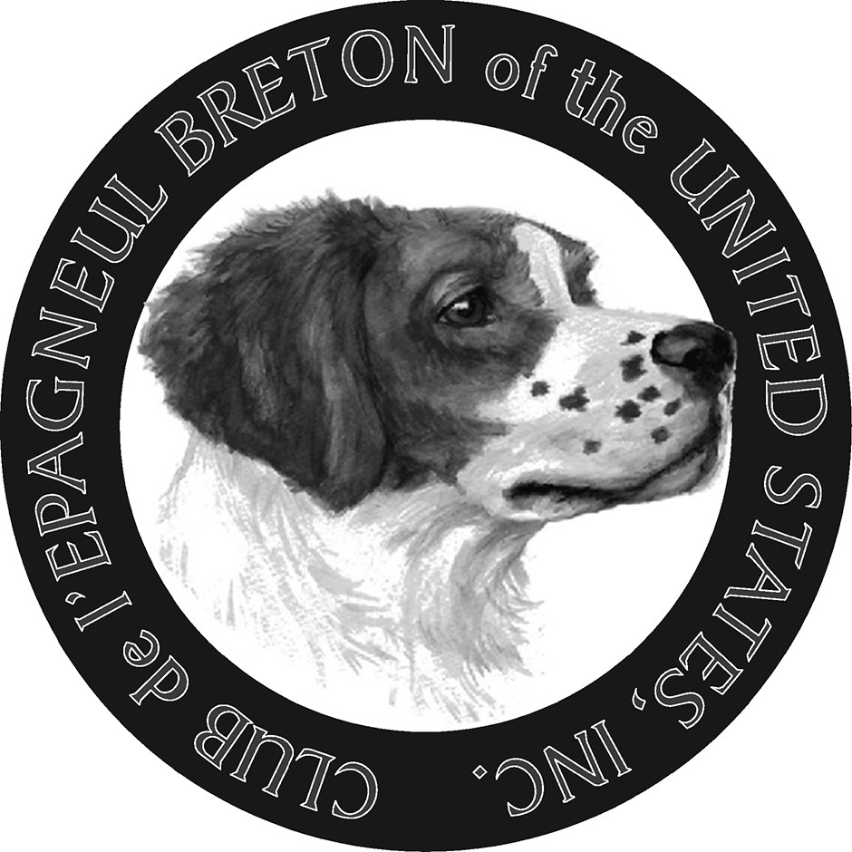

Application Form- Joyce Smith Memorial Scholarship
This Application Form, along with the Certification and Release/Acknowledgements Form to be signed by the Applicant and a Parent of Applicant must be completed by prospective applicants who are entering college freshmen and should be forwarded, with any supporting materials to the chairman of the Joyce Smith Memorial Scholarship Committee for CEB-US. Due date for submission is by February 15 of the year in which the applicant plans to enter college. The intent of the scholarship is to recognize young people who have been substantially involved with and made contributions towards advocating and advancing the interests of the Epagneul Breton breed and who have participated in the activities of CEB-US and affiliated regional clubs. The Scholarship Committee of CEB-US reserves the right in its discretion to award or withhold awarding the scholarship on an annual basis, based on the degree of demonstrated involvement with the Epagneul Breton and CEB-US and affiliated local clubs by prospective scholarship applicants. While involvement and advocacy for the breed may be demonstrated in many ways in addition to participation in shows or field trials, demonstration of reasonable involvement with the Epagneul Breton and participation in CEB-US and affiliated regional clubs over a sustained period of time prior to submission of this application are criteria which will be considered by the Scholarship Committee for awarding the scholarship.
The Essay portion of this application will be published in L’Epageneul Breton (the CEB-US semiannual magazine publication) along with a short article about any scholarship recipient. The scholarship is awarded annually to applicants deemed qualified by the Joyce Smith Memorial Scholarship Committee and is conferred on behalf of the Club De L’Epagneul Breton of the United States, Inc. (“CEB-US”). The scholarship fund is managed for investment and the scholarship proceeds are disbursed to approved applicants by The Epagneul Breton Foundation, Inc. which is an approved 501(c)(3) charitable entity under the regulations of the Internal Revenue Service of the United States.
*Please note: If your answer to any question requires additional space beyond that provided in the application form you may attach additional pages, along with exhibit’s, photos or supporting materials to the application.

- Name and Address of Applicant.
______________________________________________________________________________
______________________________________________________________________________
Email_______________________________ and telephone______________________________

- Have you been a youth member of CEB-US? _______ If so, what years?_________ Alternatively, have you participated as a member of your family under a Family CEB-US Membership?____ If “yes”, name of family members and since what year has your family held a membership in CEBUS?______________________________________________________________________________________________________________________________________________________

- Name and Address (including City, and State) of High School
______________________________________________________________________________

*High School GPA. ________________ *Class Rank (approx. if exact rank is not known) _______
*Most recent as of date of this application.
Name of College or University to be attended: ____________________________
Date of application _____and date of acceptance by college/university*____________________
*If known at time of application
- Please list below all activities you have participated in with the Epagneul Breton which have been sponsored by CEB-US or any affiliated local or regional UKC pointing dog club associated with the Epagneul Breton. (For trials, shows, seminars or training days please list the type event, and month and year.
______________________________________________________________________________ ______________________________________________________________________________ ______________________________________________________________________________
______________________________________________________________________________ ______________________________________________________________________________
______________________________________________________________________________
- Please list below all activities you have participated in with the Epagneul Breton which were sponsored by some entity or sponsoring organization other than CEB-US or an affiliated local/regional UKC Pointing Dog club affiliated with the Epagneul Breton by including the event type, date(s) and year(s). (i.e. AKC, NAVDHA, NSTRA, Four- H Club, or any other school, agricultural ,
Canine,or community organization.) _____________________________________________________________________________________________________________________________________
______________________________________________________________________________ ______________________________________________________________________________ ______________________________________________________________________________
______________________________________________________________________________
______________________________________________________________________________

- Please list and explain any programs, forums, publications, media or events of any kind which you have taken part in to promote or educate the general public or any group about the Epagneul
Breton breed, if any. (Please supply any brochures, newspaper or magazine articles, type of media format, location on the internet, or other documentation, if available.)
______________________________________________________________________________
______________________________________________________________________________
______________________________________________________________________________
______________________________________________________________________________
2 of 3

- Please succinctly explain in the space below the length and extent of your personal involvement with the Epagneul Breton separate than what is contained in your essay written as a part of this application. (i.e., Training your dog, hunting your dog, showing your dog, field trialing your dog, or participation in any other sanctioned event or any additional involvement working with
Epagneul Bretons on an ongoing basis.)
______________________________________________________________________________
______________________________________________________________________________
______________________________________________________________________________
______________________________________________________________________________
______________________________________________________________________________
______________________________________________________________________________

- Please attach to this application a typed essay written by yourself of not less than 1000 words or more than 3000 words, which details and recounts your experiences with Epagneul Bretons and the impact of the involvement with the Epagneul Breton in your own life. Each essay should contain a title chosen by the applicant.

- Please submit three (3) to five (5) photographs of you and your Epagneul Breton(s) which depict activities or experiences where you are involved with your dog(s). These should be in a format which can be supplied by email for possible publication.
The information contained above and submitted with my application is true, accurate and correct to the best of my knowledge and is current as of this date. I hereby apply for consideration of being awarded the Joyce Smith Memorial Scholarship based upon the criteria established by the CEB-US Joyce Smith Memorial Scholarship Selection Committee and based on the Applicant and parental Certification and Release/Acknowledgments form which must be submitted herewith.
Respectfully submitted this ____________ day of ________________________, 2___________________.

_____________________________________
Signature of Applicant
__________________________________
Print Name
*Please attach relevant Supplements, Exhibits, Photos and Essay to this application when you submit it to the Chairman of the Scholarship Selection Committee and copy the current CEB-US President. In addition to hard hard copy you may download these materials and submit them on a computer disc, thumb driver or zip file.

3 of 3

